**ET**

According to Intelli, the Liechtenstein personalized medicine devices market was valued at USD 9.8 million in 2024 and is projected to reach USD 18.4 million by 2032, growing at a CAGR of 8.2% during the forecast period.

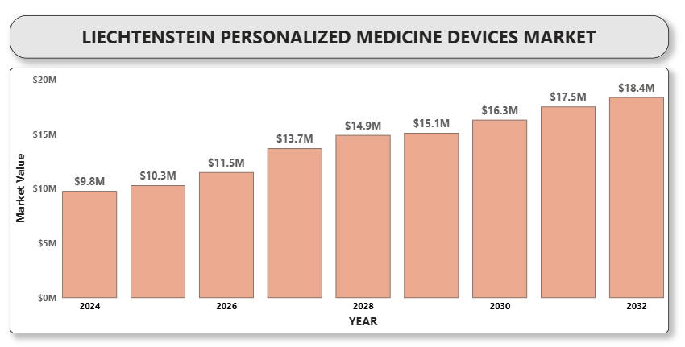

Market growth in Liechtenstein is underpinned by increasing adoption of genomics-based diagnostics, rising awareness of precision treatment pathways, and governmental interest in advanced health data analytics. The integration of personalized devices in oncology, cardiology, and rare disease management is expanding, supported by public-private partnerships and patient advocacy groups.

**Liechtenstein personalized medicine devices Market Definition**

Personalized medicine devices are tools and technologies that enable tailored diagnosis, treatment, and monitoring of patients based on their genetic, biomarker, phenotypic, or psychosocial characteristics. These devices include companion diagnostics, genomic sequencing instruments, wearable health trackers, point-of-care testing kits, and AI-enabled predictive monitoring systems.

In Liechtenstein, the demand for personalized medicine devices is driven by advancements in precision healthcare, integration of genomics into clinical practice, and a growing focus on preventive healthcare. The country benefits from strong healthcare infrastructure, cross-border collaborations, and proximity to innovation hubs in Switzerland, Austria, and Germany.

**Liechtenstein personalized medicine devices Market Overview**

The healthcare system in Liechtenstein, closely aligned with Swiss standards, facilitates the rapid introduction and adoption of cutting-edge technologies. Wearable devices for real-time health monitoring and AI-powered predictive systems are becoming increasingly popular among healthcare providers and consumers alike.

With a digitally mature population and proactive regulatory environment, Liechtenstein presents a conducive ecosystem for personalized medicine. Investment in interoperability standards, data protection, and genomic research is further strengthening the demand for precision health tools.

**Liechtenstein personalized medicine devices Market Segment Analysis**

**By Product Type**

* Companion Diagnostics
* Genomic Sequencing Devices
* Wearable Health Monitors
* Point-of-Care Testing Devices
* Digital Therapeutic Devices
* AI-Based Predictive Tools

**By Application**

* Oncology
* Cardiology
* Neurology
* Infectious Diseases
* Rare & Genetic Disorders
* Preventive Health Monitoring

**By End Use**

* Hospitals & Clinics
* Research Institutes
* Diagnostic Laboratories
* Homecare Settings
* Academic & Genomic Research Centers

**Liechtenstein personalized medicine devices Competitive Landscape**

The Liechtenstein personalized medicine devices market is characterized by niche-focused global players, biotech startups, and diagnostics innovators. Companies operating in the region emphasize compliance with European MDR regulations, CE certifications, and patient-centric innovation.

Strategic alliances with research institutions, cross-border digital health initiatives, and AI integration in diagnostics are key competitive strategies. Customization, data privacy, and interoperability with EHR systems are crucial for market differentiation.

**Key Profiles of Liechtenstein personalized medicine devices market**

* Roche Diagnostics
* Thermo Fisher Scientific
* Illumina Inc.
* Bio-Rad Laboratories
* Abbott Laboratories
* Qiagen N.V.
* Myriad Genetics
* Agilent Technologies
* Foundation Medicine
* Invitae Corporation
* Guardant Health
* Genomic Health (Exact Sciences)
* Tempus Labs
* Freenome Holdings
* SOPHiA GENETICS

**Key Developments**

* **Published on 17 June 2024**, Roche highlighted its innovative use of health data to advance oncology research and support personalized medicine—an approach focused on delivering tailored care based on an individual's genetics, environment, and lifestyle.
* **On March 20, 2024,** Bayer and Thermo Fisher Scientific announced a collaboration to develop next-generation sequencing-based companion diagnostics (CDx), aiming to expand patient access to Bayer’s precision cancer therapies through decentralized genomic testing and faster results.

**Market Attractiveness**

Liechtenstein offers a unique blend of a robust regulatory framework, high-tech adoption, and healthcare quality, making it an appealing market for personalized medicine devices. Its integration with European healthcare networks and proximity to global medtech hubs support innovation and accessibility.

**Porter’s Five Forces Analysis**

* **Threat of New Entrants:** Moderate – Requires regulatory expertise and advanced tech capabilities.
* **Bargaining Power of Suppliers:** Moderate – Specialized component and software providers play a key role.
* **Bargaining Power of Buyers:** High – Hospitals and clinics demand cost-effective, accurate, and integrated solutions.
* **Threat of Substitutes:** Low to Moderate – Few alternatives match the accuracy of personalized diagnostics.
* **A close-up of hands holding a tablet and a pen

  Description automatically generatedCompetitive Rivalry:** High – Rapid innovation and strong global presence in a small market increase competition.

**Table of Contents**

1. **Introduction of Liechtenstein Personalized Medicine Devices Market**
   * 1.1 Overview of the Market
   * 1.2 Scope of Report
   * 1.3 Assumptions
2. **Executive Summary**
3. **Research Methodology**
   * 3.1 Data Mining
   * 3.2 Validation
   * 3.3 Primary Interviews
   * 3.4 List of Data Sources
4. **Liechtenstein Personalized Medicine Devices Market Outlook**
   * 4.1 Market Definition
   * 4.2 Market Overview
   * 4.3 Porter’s Five Forces Model
   * 4.4 Value Chain Analysis
5. **Market, by Product Type**
   * 5.1 Companion Diagnostics
   * 5.2 Genomic Sequencing Devices
   * 5.3 Wearable Health Monitors
   * 5.4 Point-of-Care Testing Devices
   * 5.5 Digital Therapeutic Devices
   * 5.6 AI-Based Predictive Tools
6. **Market, by Application**
   * 6.1 Oncology
   * 6.2 Cardiology
   * 6.3 Neurology
   * 6.4 Infectious Diseases
   * 6.5 Rare & Genetic Disorders
   * 6.6 Preventive Health Monitoring
7. **A close-up of hands holding a tablet and a pen

   Description automatically generatedMarket, by End Use**
   * 7.1 Hospitals & Clinics
   * 7.2 Research Institutes
   * 7.3 Diagnostic Laboratories
   * 7.4 Homecare Settings
   * 7.5 Academic & Genomic Research Centers
8. **Competitive Landscape**
   * 8.1 Overview
   * 8.2 Company Market Ranking
   * 8.3 Key Development Strategies
9. **Company Profiles**

**9.1 Roche Diagnostics**  
9.1.1 Overview  
9.1.2 Financial Performance  
9.1.3 Product Outlook  
9.1.4 Key Developments

**9.2 Thermo Fisher Scientific**  
9.2.1 Overview  
9.2.2 Financial Performance  
9.2.3 Product Outlook  
9.2.4 Key Developments

**9.3 Illumina Inc.**  
9.3.1 Overview  
9.3.2 Financial Performance  
9.3.3 Product Outlook  
9.3.4 Key Developments

**9.4 Bio-Rad Laboratories**  
9.4.1 Overview  
9.4.2 Financial Performance  
9.4.3 Product Outlook  
9.4.4 Key Developments

**9.5 Abbott Laboratories**  
9.5.1 Overview  
9.5.2 Financial Performance  
9.5.3 Product Outlook  
9.5.4 Key Developments

**9.6 Qiagen N.V.**  
9.6.1 Overview  
9.6.2 Financial Performance  
9.6.3 Product Outlook  
9.6.4 Key Developments

**9.7 Myriad Genetics**  
9.7.1 Overview  
9.7.2 Financial Performance  
9.7.3 Product Outlook  
9.7.4 Key Developments

**9.8 Agilent Technologies**  
9.8.1 Overview  
9.8.2 Financial Performance  
9.8.3 Product Outlook  
9.8.4 Key Developments

**9.9 Foundation Medicine**  
9.9.1 Overview  
9.9.2 Financial Performance  
9.9.3 Product Outlook  
9.9.4 Key Developments

**9.10 Invitae Corporation**  
9.10.1 Overview  
9.10.2 Financial Performance  
9.10.3 Product Outlook  
9.10.4 Key Developments

**9.11 Guardant Health**  
9.11.1 Overview  
9.11.2 Financial Performance  
9.11.3 Product Outlook  
9.11.4 Key Developments

**9.12 Genomic Health (Exact Sciences)**  
9.12.1 Overview  
9.12.2 Financial Performance  
9.12.3 Product Outlook  
9.12.4 Key Developments

**9.13 Tempus Labs**  
9.13.1 Overview  
9.13.2 Financial Performance  
9.13.3 Product Outlook  
9.13.4 Key Developments

**9.14 Freenome Holdings**  
9.14.1 Overview  
9.14.2 Financial Performance  
9.14.3 Product Outlook  
9.14.4 Key Developments

**9.15 SOPHiA GENETICS**  
9.15.1 Overview  
9.15.2 Financial Performance  
9.15.3 Product Outlook  
9.15.4 Key Developments

1. **Key Developments**
   * 10.1 Product Launches/Developments
   * A close-up of hands holding a tablet and a pen

     Description automatically generated10.2 Mergers and Acquisitions
   * 10.3 Business Expansions
2. **Appendix**
   * 11.1 Related Research